# Introduction

The way that this guide is written and set up is the order in which I had set up and acquired the different materials.

# Software Setup

The first thing to do when setting up everything for the raspberry pi to work functionally and as intended is to get the micro SD card and install the raspbian OS onto it. This can be done from the raspberry pi website and you simply download the software, run it, select the OS (raspbian OS) and select the micro SD as the target for the installation. The following link is used to show how to install the OS. You should enable VNC in the preferences for later ease of use and access.

[Set up your SD card | Setting up your Raspberry Pi | Coding projects for kids and teens](https://projects.raspberrypi.org/en/projects/raspberry-pi-setting-up/2)

Once the OS is installed on the micro SD card and verified you will need to plug it into the Pi. After this you plug it into a monitor with the appropriate inputs, mouse, HDMI, and power, to finalize the installation onto the micro SD card. There are only so many ports so I recommend using a mouse and not a keyboard for the installation process. for the mouse to work I found that the usb port closest to the micro HDMI port worked while the other did not. An adapter is required to connect the micro HDMI to a regular HDMI cable.

Once you the Raspberry Pi is plugged into everything, turn it on and then the screen should show the Raspberry Pi desktop. From here you finalize the installation and the Raspberry Pi is ready to be used.

While setting up the Pi for the username and password the following were chosen:

username: torito

password: SOARtorito

hostname: toritoPI

When setting up the Pi and booting into it I had to open the start menu, go into the preferences and enable SSH.

Once that is done you can make it a headless setup by doing the following:

1) Make sure that your computer and the Pi are connected the same internet connection

2) Plug in the Pi into your computer you want to connect to

3) Download PuTTY or another terminal application

4) Open PuTTY and enter the hostname.local, toritoPI.local

5) Login using the credentials provided above, torito SOARtorito

With this you will no longer have to connect a keyboard, mouse, HDMI or power cable (because the power comes from your pc) to the Pi and just program and run programs directly from the connection established.

### Troubleshooting

Some troubleshooting I encountered while connecting to the Pi is that it may take a while to boot so you may have to wait a couple of minutes before connecting to the Pi. Another thing is to make sure that the green light is on that tells you the Raspberry Pi is on and receiving power, if it is not on then the Pi and off and you should try a different port.

# Plumbing System

For the solenoid valve I went to a store and purchased a 1 ⁄ 4 '' Hose barb, this is so that I could connect the solenoid valve to the hose to transport water in. I had to remove the old fittings from the solenoid because they would not fit traditional plumbing sizes in the US, most thought the old fittings were metric. Then a hose was bought to transfer the water from the garden hose connected to a house to the solenoid valve. Clamps were also purchased so that the hose would not come flying off when putting water through it to the garden hose.

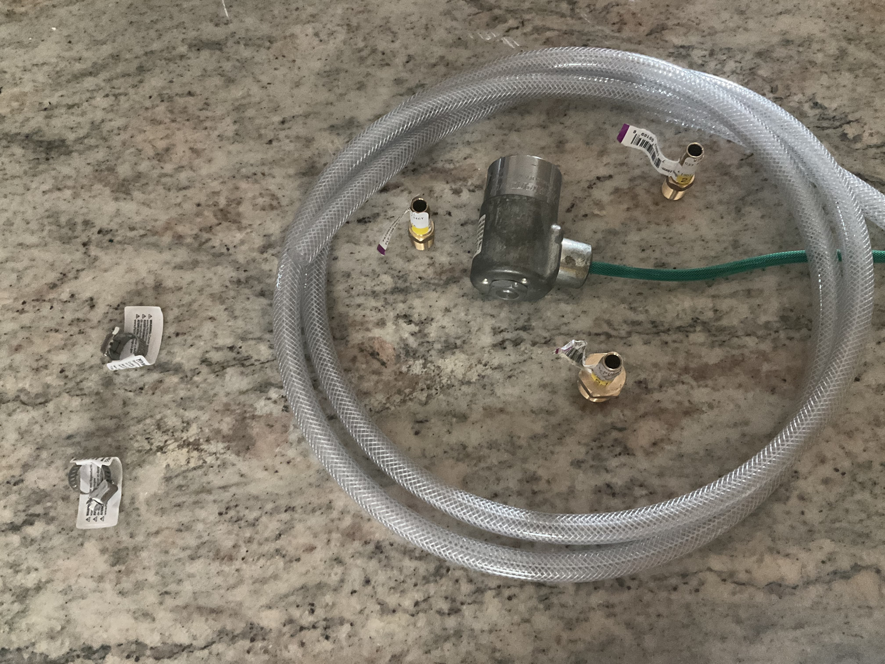

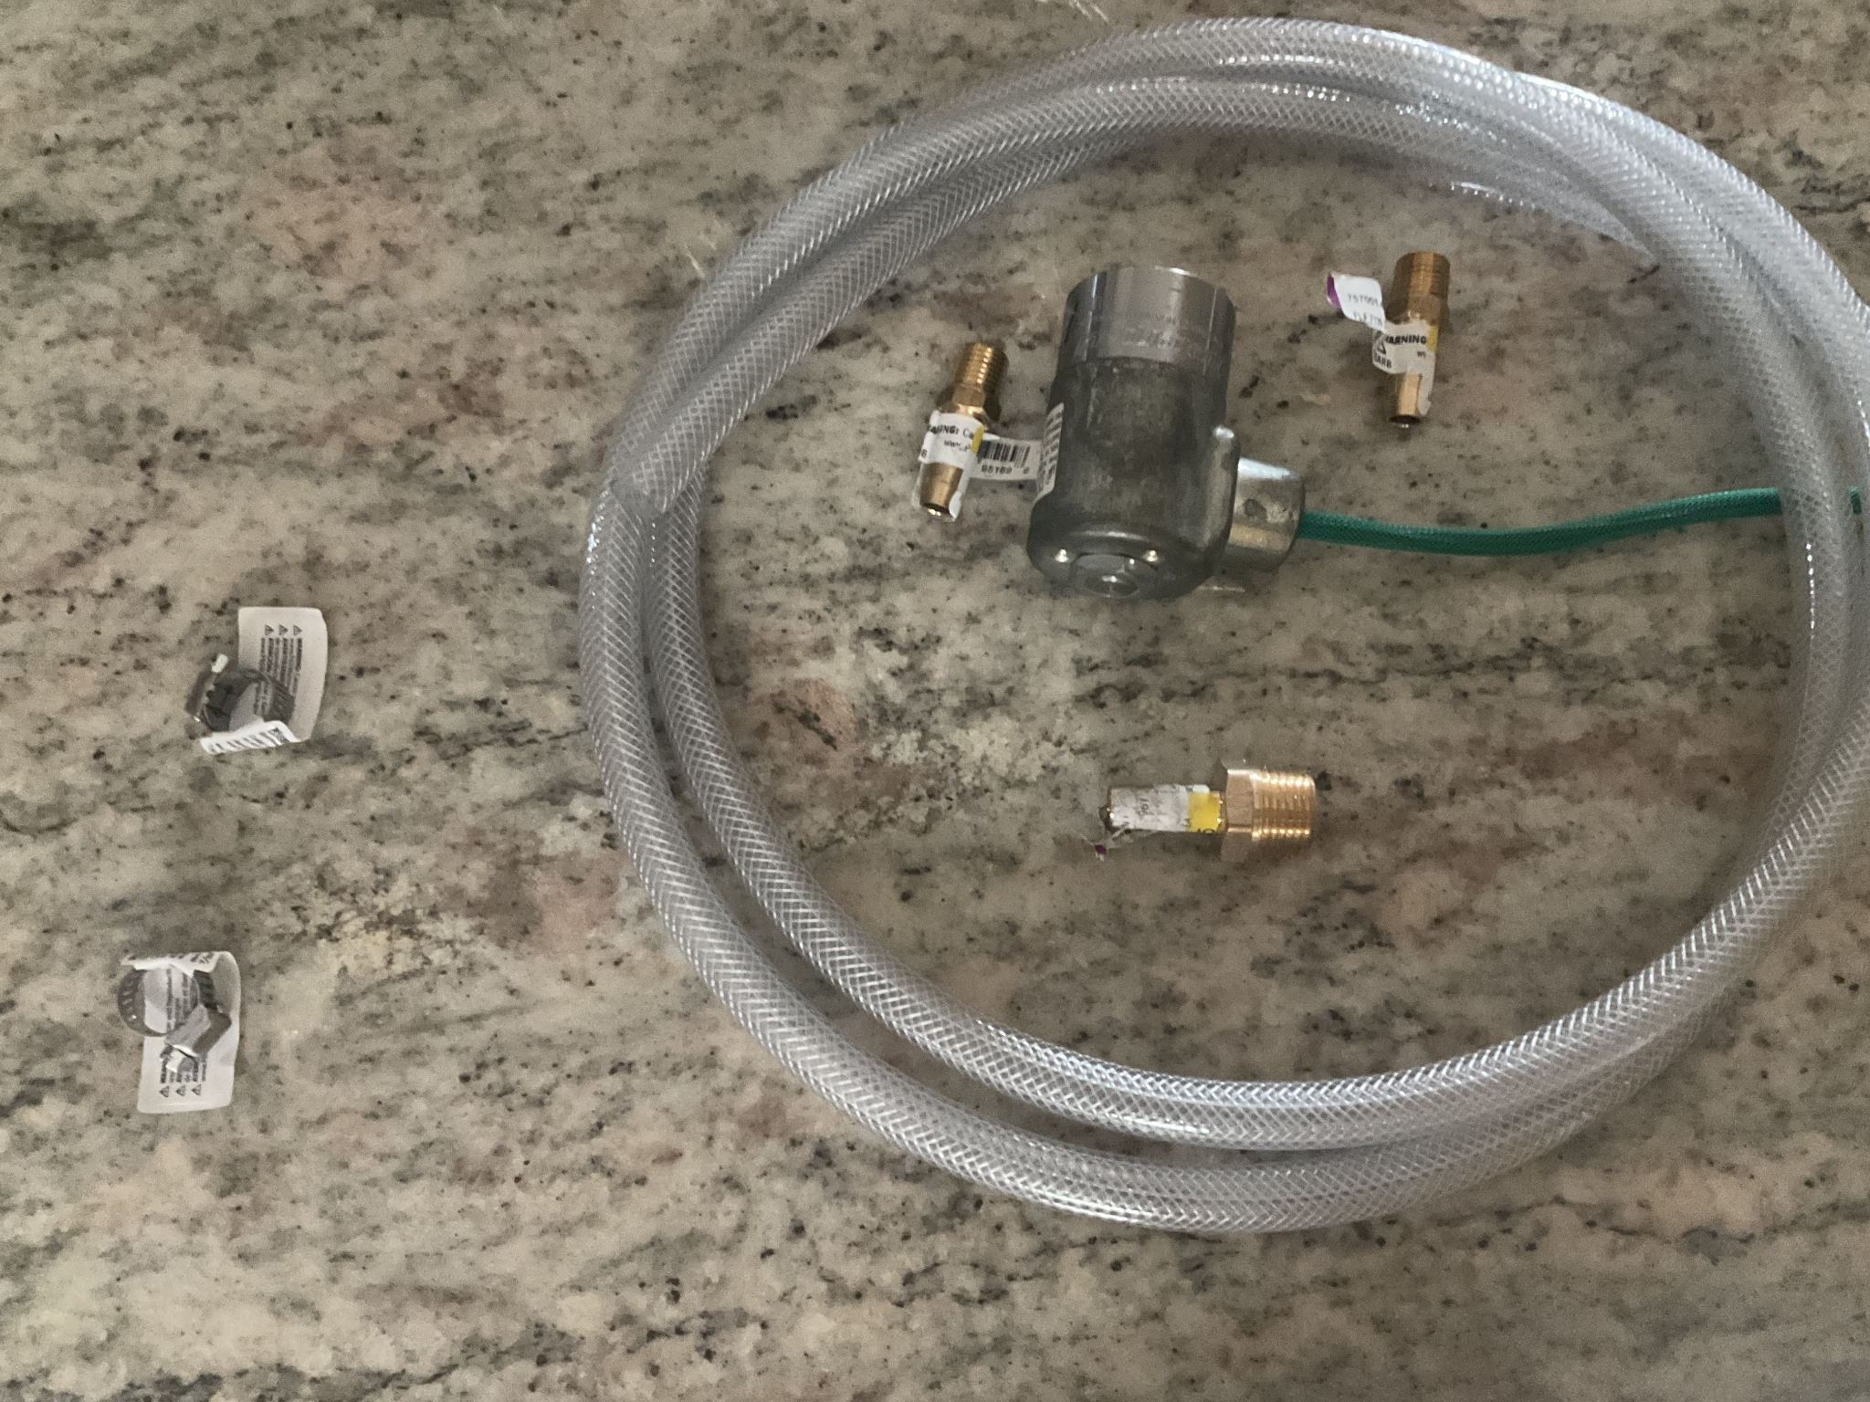

These pictures show the parts before assembly and before any tests will be done.

A 9V battery was used and tested to see if there is any clicking sound coming from the solenoid valve and there was. The test will be done using a 9V battery to test if water can flow through the solenoid valve, if it cannot allow water to flow through then the voltage will be increased to 24V as the solenoid valve describes. If water still does not flow through the valve then the valve will be deemed as defective.

# Programming the GUI and Control System

When programming the GUI I had to use pip to install matplotlib and opencv-python so that the display can be rendered in showing the GUI. When troubleshooting for opencv-python the link that I used to figure out how to properly install it is below. Make sure to install the dependencies before trying to install opencv through pip. If you do not install the dependencies then the installation can take many many hours.

[Installing OpenCV | The Raspberry Pi Guide (raspberrypi-guide.github.io)](https://raspberrypi-guide.github.io/programming/install-opencv)

Another error run into was when the process of installing opencv had failed and been killed by the raspberry pi, the way to counteract this is to use the --no-cache-dir flag in the pip command. The final command should look something like pip install opencv-python --no-cache-dir if you run into this problem.

When troubleshooting everything regarding tkinter and the GUI for the raspberry pi because it is a headless setup you must go into the raspberry pi configuration using raspi-config to get to the configuration and enable VNC, this setting will be under interface options. You also need to install a VNC viewer so that the GUI can work. Once that is done you create a new connection under file and enter the hostname, username, and password and the connection will be established. There is a link below demonstrating how to establish a connection and set up this connection.

[Headless Setup of Raspberry Pi without Keyboard and Monitor - YouTube](https://www.youtube.com/watch?v=fPpZUeui8y8)

The GUI is created using the tkinter python library since it is the one most familiar with. For the GUI setup it will be very simple, it will be two buttons, an open and a closed with a title at the top to show if the solenoid valve is open or closed. The buttons will also control the output of the GPIO pins to make sure the solenoid valve is open and closed respectively. The following image is the code being used to showcase the GUI as well as how the solenoid valve is controlled in the program code.

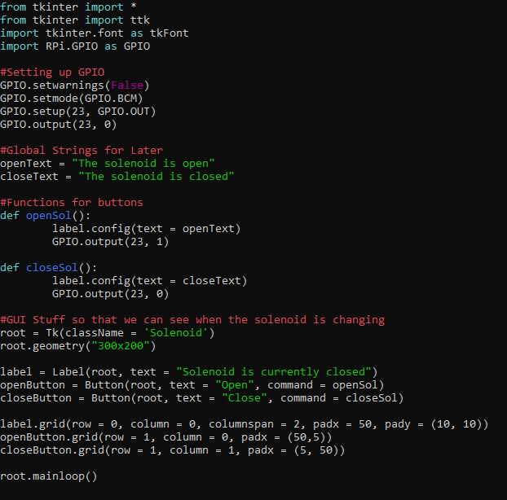

This is an image of the circuit being used to control the solenoid valve.

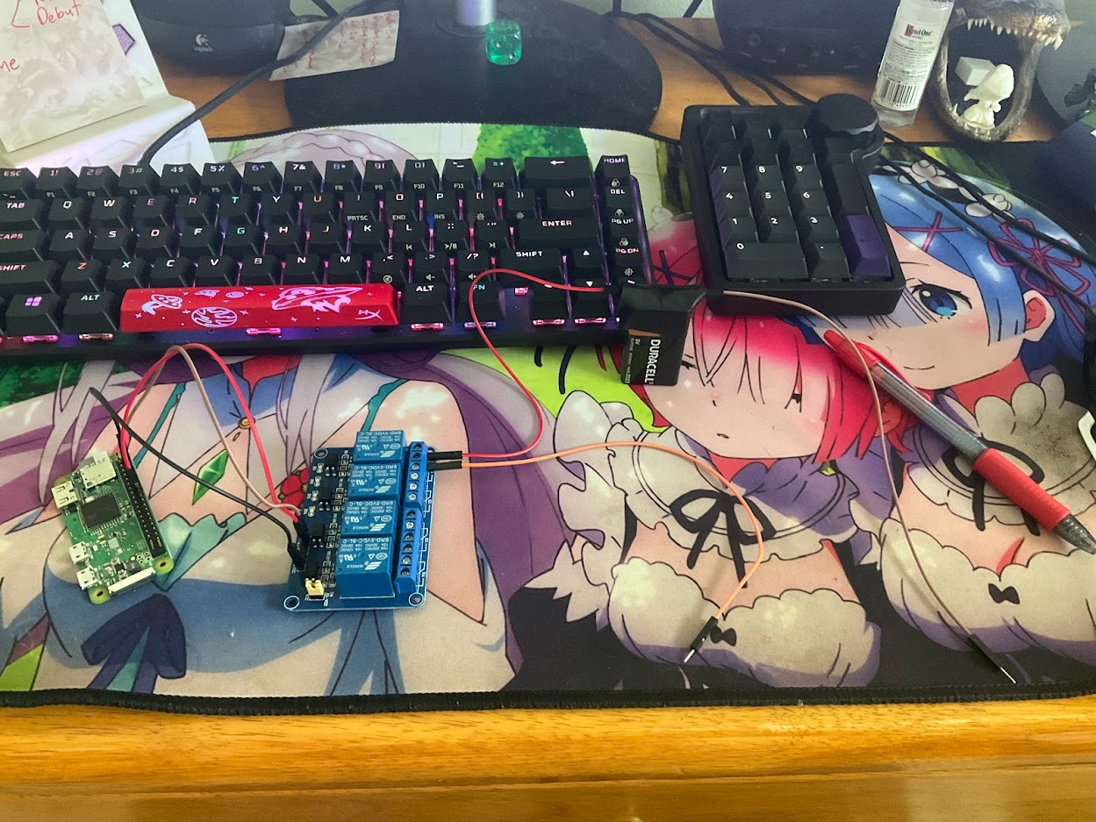

The raspberry pi is powering the relay module seen as well as giving it signal when to allow power to flow through it and when not to.

The following is a video of a dry test being conducted to make sure that the relay as well as the GUI is working as intended and is functional.

<https://youtu.be/qX4IQKeh3JE>

As seen in the video the GUI works and showcases that the solenoid is only open, receiving voltage when the relay is open or the GPIO pin is given a high signal, 1.The reason that there is clicking when the solenoid is being connected is because the connection is not solid and to counteract this is to use electrical tape with the ends of the wires with the connections on the solenoid valve.

As noted in the video there were instances of the solenoid clicking multiple times and to counter this electrical tape was used to secure the connections between the relay wires and the solenoid and as a result the solenoid only clicked once when the voltage was allowed to pass through. The next step in the process is the water flow test using the pipes and garden hose.

# Water Flow Test

For the final flow test the system for the intake and outtake of water is going to be a hose with pipes going into and out of the solenoid valve. The intake pipe is shown on the left side of the solenoid and the outtake tube is on the right side of the solenoid. There is a connector at the end of the intake pipe that is used to connect to a garden hose to allow for water to flow through the pipe to the solenoid. An image is shown below showcasing how the system is set up.

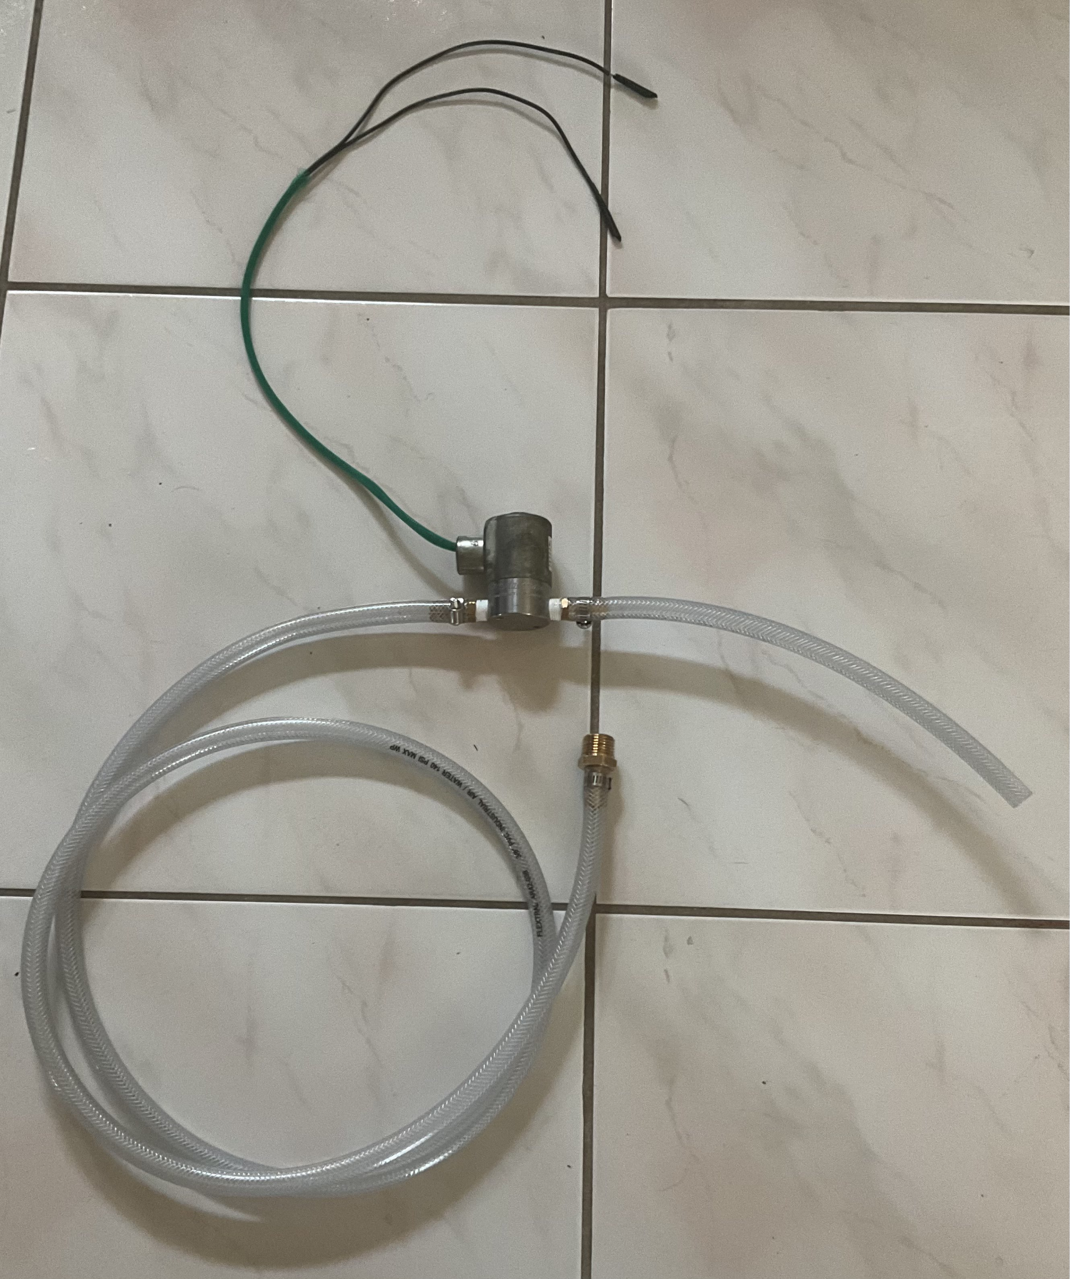

The intake tube is larger than the outtake tube, because the outtake can be more controlled in where it will be heading, while the intake is connected to a garden hose and leaks can occur. The reason the intake is so far from the solenoid is so that if there is a potential leak from the hose the electronics will be protected from any possible liquids.

Link for the Final Flow test of the system: <https://youtu.be/yb9Xfsx6qFs>

In conclusion the water flow test was successful in allowing water to flow when the solenoid was open and stop flow when the solenoid was closed. There was a problem with the solenoid I believe that did not allow all the water to go through the valve as I had the hose turned to allow significant amounts of water through the valve. Overall though water did flow through the solenoid when open as stated previously confirming that the system designed does work as intended including working with a 9V battery. When controlling the solenoid through the VNC Viewer to see the GUI made for controls the delay between the two systems was minute however simulink will be performed to find out the exact details of the delay and response time of the system.